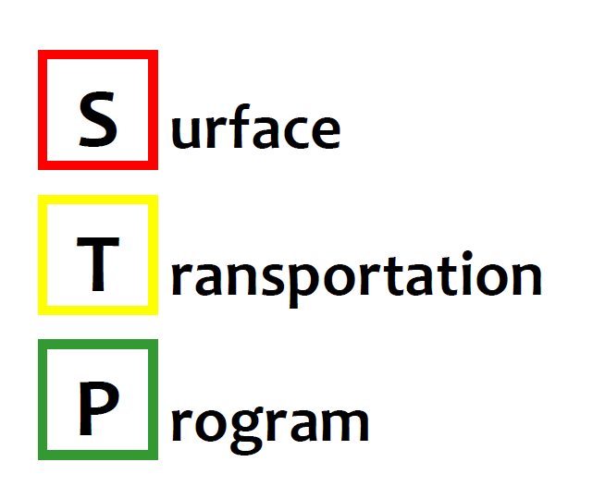

DUPAGE MAYORS AND MANAGERS CONFERENCE
an association of municipalities representing 1,000,000 people

1220 Oak Brook Road
Oak Brook, Illinois 60523
(630) 571-0480
Fax: (630) 571-0484
www.dmmc-cog.org

MEMBER
MUNICIPALITIES
Addison
Aurora
Bartlett
Bensenville
Bloomingdale
Bolingbrook
Burr Ridge
Carol Stream
Clarendon Hills
Downers Grove
Elmhurst
Glen Ellyn
Glendale Heights
Hanover Park
Hinsdale
Itasca
Lemont
Lisle
Lombard
Naperville
Oak Brook
Roselle
Schaumburg
Villa Park
Warrenville
Wayne
West Chicago
Westmont
Wheaton
Willowbrook
Winfield
Wood Dale
Woodridge
Founded June 19, 1962
DMMC STP Scoring Supplement Form – Trail Projects
Applications for the FY2021-FY2025 DMMC STP Call for Projects will be submitted through CMAP’s eTIP (https://etip.cmap.illinois.gov/secure/login). Applicants are also required to fill out this scoring supplement form so that DMMC can score submitted applications. Please contact Daniel Knickelbein at 630-571-0480 ext. 226 or dknickelbein@dmmc-cog.org with any questions.
Applicants should fill out this form if they are submitting a trail application. As defined in DMMC’s STP Handbook, a trail project is a bikeway physically separated from motorized vehicular traffic by an open space or barrier and either within the highway right-of-way or within an independent right-of-way. A trail project must have a transportation purpose.

Note: Applications submitted by DuPage County, DuPage County Forest Preserve, or a township must be co-sponsored by a municipality. Municipal co-sponsorship should be demonstrated by a letter of support from one or more affected municipalities and should be uploaded to the eTIP at the time of application submittal.

1. Project Connectivity (20 Points): Please select the connectivity of the proposed project to an existing trail:
Connects two existing trail sections ☐
Extends an existing trail or provides a new connection to an existing trail ☐
Proposed trail does not connect to an existing trail ☐
2. Market for Facility (15 Points): Points in this category will be awarded based on the population and employment density in the area served by the facility. Points will be assigned using CMAP’s Market for Facility Map, which can be found here. Applications will be scored using the project location as submitted in the eTIP.
3. Project Readiness (15 Points): Documentation of Phase I engineering status and Right-of-Way certification (if applicable) will need to be submitted for the project to earn points. Please upload correspondence with IDOT BLRS confirming Phase I engineering status and ROW acquisition (if applicable) to the eTIP.
Phase I Status:
No activity ☐ Phase I Kickoff Meeting Held ☐
Phase I Engineering Report (PDR) Draft Submitted to IDOT ☐ Phase I Engineering Complete ☐
ROW Status:
ROW Needed and Not Acquired ☐ ROW Not Needed or ROW Acquired ☐
4. Local Needs (10 Points): Please select the number of years since the project sponsor has been awarded an STP project through DMMC (HWY or TCM):
0-4 years ☐ 5-7 years ☐ 8-9 years ☐ 10+ years ☐
5. Financial Commitment (10 Points): Please select the percentage of non-DMMC funds (local, state, federal) committed as a percentage of the federally eligible share of total construction and CE costs. If the project contains other federal and state funds, documentation should be uploaded to the eTIP.
25-29 % ☐ 30-39 % ☐ 40-49 % ☐ 50% + ☐
6. Consistency with Adopted Plans (5 Points): Please select whether this project is included in an adopted plan. An adopted plan could be statewide, regional, or local. Documentation of inclusion in an adopted plan should be uploaded to the eTIP.
7. Complete Streets Planning Factor (5 Points): Please indicate whether the project sponsor has an adopted Complete Streets policy. Documentation of an adopted Complete Streets policy should be uploaded to the eTIP.
Complete Streets Policy:
Yes ☐ No ☐

8. Green Infrastructure Planning Factor (10 Points): Please select below whether the project will contain one or more of the following Green Infrastructure elements. Documentation of an adopted Green Infrastructure policy should be uploaded to the eTIP.
Green Infrastructure Policy ☐ Pervious Pavement ☐
Infiltration trench/bioretention cell/bioswale ☐ Vegetated filter strips ☐
One or more engineered stormwater Best Management Practices (BMPs) ☐
9. Inclusive Growth Planning Factor (5 Points): Points in this category will be awarded based on the percentage of low to moderate income residents in the Block Group where the project is located. Data from this category will come from the DuPage County Low to Moderate Income Block Groups GIS webpage, which can be found here. Applications will be scored using the project location as submitted in the eTIP.
10. Transit Supportive Land Use (5 Points): Points in this category will be awarded based on the area of the project location and proximity to transit. Proximity to transit will be measured by proximity to a Metra Station or Pace Bus stop. Applications will be scored using the project location as submitted in the eTIP.

